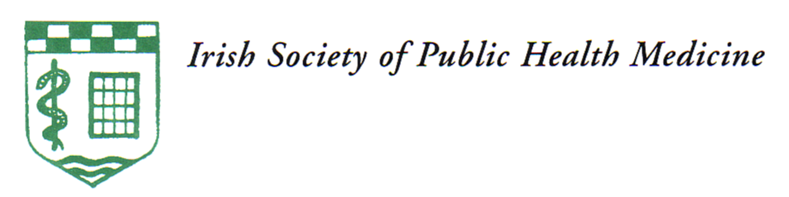
IRISH SOCIETY OF
COMMUNITY AND PUBLIC HEALTH MEDICINE

Annual Scientific Meeting and AGM

Thursday 3rd and Friday 4th October 2024
The Gresham Hotel (Riu Plaza), 23 O’Connell Street Upper, Dublin D01C3W7

E-mail registration form

1.Complete form in white areas
2.Click on File
3.Click on Save & Send
4.Select Send as an Attachment
5.Email to treasurer@iscphm.ie
Name: | Dr
Medical Council Registration Number
Address:
Telephone number:
Email address:
area of work | X
Community Medicine
Public Health
Retired
Attending: | X | Employed: | Retired: | Includes annual member registration fee of €30.00  If you wish to register as member without attending please pay €30.00
Full conference |  | €250 | €125
Day 1 only |  | €150 | €75
Day 2 only |  | €110 | €55
After submitting your registration form please pay on-line:

Payee name: ISCPHM

IBAN: IE73 BOFI 9000 1715 8596 43

Reference: Your name and medical council registration number.
(This is essential for matching your payment to your registration form)

If you require an alternative payment option please email Gretta Tarrant at treasurer@iscphm.ie
A receipt of payment will be emailed with CPD certs following the meeting.

