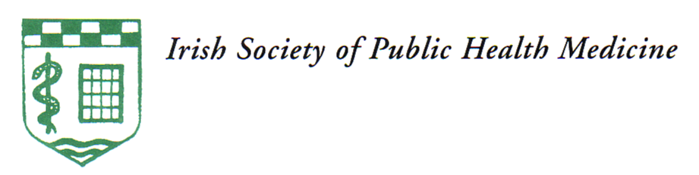
IRISH SOCIETY OF
COMMUNITY AND PUBLIC HEALTH MEDICINE

Munster Branch Annual Educational Meeting

Tuesday 6th May 2025
Maryborough Hotel, Maryborough Hill, Douglas, Cork, T12 XR12

Please e-mail registration form to louise.fullam@hse.ie and pay online (details below)

Name: | Dr
MCRN:
Address:
Telephone number:
Email address:
Dietary requirements:
area of work | X
Community Medicine
Public Health
Retired
After submitting your registration form please pay on-line:
Fee: €85

Payee name: Munster Branch of the Irish Society of Community and Public Health Medicine

IBAN: IE68BOFI90280587203512

BIC: BOFIIE2D

Reference: Your name and medical council registration number.
(This is essential for matching your payment to your registration form)

If you require an alternative payment option please email louise.fullam@hse.ie
A receipt of payment will be emailed with CPD certs following the meeting.

